Canadian Railroad Trilogy Capo 1
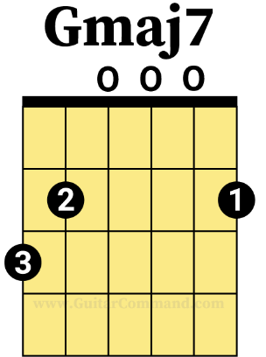
Gordon Lightfoot

Verse:
G C
There was a time in this fair land
G(12)
When the railroad did not run
Gmaj7 C
When the wild majestic mountains stood
D(12)
Alone against the sun
G C G(12)
Long before the white man and long before the wheel
G D
When the green dark forest was
F G Dm G Dm G(8)
Too silent to be real

G C G(12)
But time has no beginnings and the history has no bounds
Gmaj7 C D(12)
As to this verdant country they came from all around
G C G(12)
They sailed upon her waterways and they walked the forests tall
G D Built the mines, the mills and the factories
F G Dm G Dm G(8)
For the good of us all
G C G(12)
And when the young man's fancy had turned into the spring
Gmaj7 C D(12)
The railroad men grew restless for to hear the hammers ring
G C G(12)
Their minds were overflowing with the visions of their day
G D
With many a fortune won and lost
F G(12)
And many a debt to pay

Chorus (4/4 half time):
D Am
For they looked in the future and what did they see
F G
They saw an iron road running from the sea to the sea
D Am
Bringing the goods to a young growing land
F G(8)
All up from the seaports and into their hands

Bridge:
F G F G
Look away said they across this mighty land
F G F G
From the eastern shore to the western strand

Chorus:
D Am
Bring in the workers and bring up the rails
F G
We gotta lay down the tracks and tear up the trails
D Am
Open her heart let the life blood flow
F G
Gotta get on our way 'cause we're moving too slow

D Am
Bring in the workers and bring up the rails
F G
We gotta lay down the tracks and tear up the trails
D Am
Open her heart let the life blood flow
F G
Gotta get on our way 'cause we're moving too slow
F D (12 beats, fade)
Get on our way 'cause we're moving too slow

Bridge (3/4 time!):
G G C D
Behind the blue Rockies the sun is declining
G C
The stars they come stealing
A D D7
At the close of the day
G G7 C D
Across the wide prairie our loved ones lie sleeping
G C D G(6)
Beyond the dark oceans in a place far away

G G C D
We are the navvies who work upon the railway
G C A D D7
Swinging our hammers in the bright blazing sun
G G7 C D
Living on stew and drinking bad whiskey
G C D G(6)
Bending our backs til the long days are done

G G C D
We are the navvies who work upon the railway
G C A D D7
Swinging our hammers in the bright blazing sun
G G7 C D
Laying down track and building the bridges
G C D(6) G
Bending our old backs til the railroad… is done

Chorus (4/4 half time, slowly speeding up):
D Am
So over the mountains and over the plains
F G
Into the muskeg and into the rain

D Am
Up the St. Lawrence all the way to Gaspe
F G
Swinging our hammers and drawing our pay
D Am
Drivin' 'em in and tying them down
F G
Away to the bunkhouse and into the town
D Am
A dollar a day and a place for my head
F D(8)
A drink to the living, a toast to the dead

Bridge:
G Dm G
Oh the song of the future has been sung
Dm G
All the battles have been won
Dm G
On the mountain tops we stand
Dm G
All the world at our command
Dm G
We have opened up the soil
Dm(1) D(8)
With our teardrops... and our toil

Verse:
G C
There was a time in this fair land
G G
When the railroad did not run
Gmaj7 C
When the wild majestic mountains stood
D(12)
Alone against the sun
G C G(12)
Long before the white man and long before the wheel
G D F G(8)
When the green dark forest was too silent to be real
G D F G(8)
When the green dark forest was too silent to be real
G D(1) (long pause)
And many are the dead men
F(16) G

Outro?
Dm G Dm G
too silent... to be real

