May 26, 2020
Hi Jocelyn,

I had a lovely chat with your grandmother yesterday. You and I are 3rd cousins. This is how we are related:

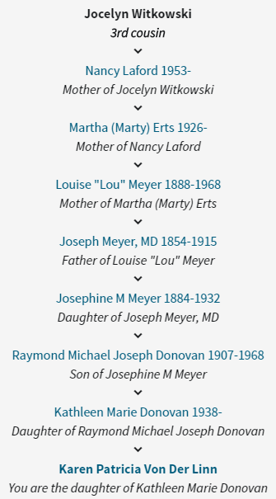

As your grandmother may have told you, I am working on a Donovan-Meyer history book for my mom. I would very much like to have copies of any old pictures that your grandmother, mother, or aunt may have (such as Marty’s wedding photos). I do have photos of most of the people in the above list, which you can see at http://nwnative.us/Karen/Genealogy/DonovanPhotos/. I also have an extensive family tree that I would be happy to share with you, as well as the book when it’s done.

You can contact me in any of the following ways:
karen@nwnative.us
425-941-3737 (Pacific time zone)
9017 Slater Ave NE Kirkland WA 98033

I very much hope to hear from you!

