June 16, 2020
Hi Lauri,

I think we are 3rd cousins. Are you the granddaughter of Esther Louise Schoenig? If so, please read on!

Our shared ancestors are Ferdinand and Magdalena Erschen. This is how I believe we might be related:

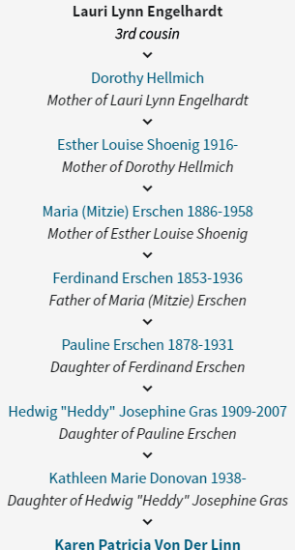

I am working on a family history book for my mom. We have never known much about my great grandmother, Pauline Erschen. We never knew that she had siblings. I have recently learned a lot about where Pauline was born, and her ancestors going back several generations. I am eager to find any additional stories or photos. Is your mother still alive? Does she know anything about other members of Mitzie Erschen’s family? Does anyone in your family have any old photos? I’d love to share my research with you.

You can contact me in any of the following ways:
karen@nwnative.us
425-941-3737 (Pacific time zone)
9017 Slater Ave NE Kirkland WA 98033

I very much hope to hear from you!

Karen Story
Born 1959

