May 26, 2020
Hi Mark,

I think we are 2nd cousins once removed. Are you the grandson of Joseph Raymond Donovan and the great grandson of Cornelius Donovan and Mary Hewitt? If so, please read on!

Our shared ancestor is Cornelius Donovan. This is how I believe we are related:

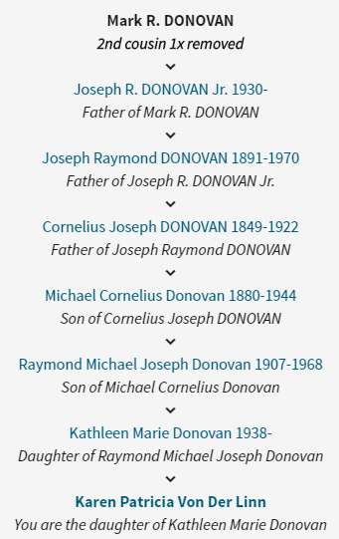

I am working on a Donovan history book for my mom. I’m hoping you might have information or anecdotes about your predecessors, or any old photographs. I do have several photos of your grandfather, which you can see at http://nwnative.us/Karen/Genealogy/DonovanPhotos/. I also have an extensive family tree that I would be happy to share with you, as well as the book when it’s done.

You can contact me in any of the following ways:
karen@nwnative.us
425-941-3737 (Pacific time zone)
9017 Slater Ave NE Kirkland WA 98033

I very much hope to hear from you!

