Pauline Erschen
Pauline Erschen was born June 23, 1878 in Grafenfeld, Gottschee, Austria (now Dolga Vas, Slovenia). She was the oldest of 10 children.
Pauline moved to Nidermösel (now Kočarji, Slovenia) with her family when she was about 14. Nidermösel is in the township of Obermösel, and the parish of Mösel (Mozelj). Her parents are buried in the Mozelj cemetery.

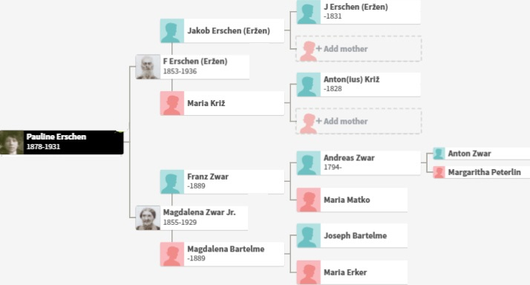
Pauline Erschen’s ancestors
Pauline’s parents were Ferdinand Erschen and Magdalena Zwar. The name Erschen is German, and Zwar is Slav. Eržen and Cvar are the respective Croatian and Slovene spellings of these names, found in some records.

Ferdinand Erschen
Ferdinand Erschen was born April 30, 1853 in Gorači, Croatia, in the parish of Čabar, just a few kilometers from the Gottschee border. His parents were Jakob Eržen and Maria Križ. The Eržen family lived in house #5.
Jakob Eržen is the son of Joannes (Ivan) Eržen, who died in 1831. Maria is the daughter of Antonius Križ from Tropeti. Gorači and Tropeti are neighboring villages.
Jakob and Maria were married in 1828. Both fathers attended the wedding, but neither mother, so they had probably died. Jakob and Maria had about a dozen children. Ferdinand was the youngest, and was born almost 25 years after his parents’ wedding.
Pauline’s daughter Heddy was told that Ferdinand was a French architect and bridge builder, and that a small town in France was named for him. I have not been able to find any information that corroborates this.
Ferdinand died in 1936 at age 83. His death record says he was a "gostač" which means wage laborer in Slovene. He did own land (5/8 of a hube, which is just over 31 acres), but it may not have been enough to support his family, so he may also have worked as a hired hand. He died of “old age and weakness.” He is buried in the Mozelj cemetery.

Magdalena Zwar
Pauline Erschen’s mother, Magdalena Zwar, was born in Grafenfeld, Austria (now Dolga Vas, Slovenia). Her family lived in house #36.
Magdalena Zwar’s parents were Magdalena Bartelme and Franz Zwar. They also had a son named Franz.
Magdalena Bartelme’s parents were Joseph Bartelme and Maria Erker. Joseph and Maria had two daughters, but Magdalena’s sister died at age 30. After Joseph died, Magdalena Bartelme’s husband, Franz Zwar, inherited the Bartelme house (Magdalena couldn’t inherit because she was a woman).
Magdalena Zwar’s father, Franz Zwar, was originally from Seele (now Željne, Slovenia), house #45. When he married Magdalena Bartelme in 1854, he moved to her family home at #36 in Grafenfeld, not far from Seele. As mentioned above, he inherited the Bartelme house after his father-in-law died.
Franz Zwar was the son of Andreas Zwar and Maria Matko. They were both born in Zadolje and moved to Seele sometime around 1830.
Andreas Zwar was born in 1794 to Anton Zwar and Margaritha Peterlin, who lived at house #1 in Zadolje. The 1824 roster of household heads lists 29-year-old Andreas as the “paterfamilias.” This likely means that Anton had died.
Magdalena Bartelme died in 1889, and Franz predeceased her.

Ferdinand and Magdalena Erschen
Ferdinand and Magdalena’s marriage may have been arranged, as was common at the time. This way the parents of the bride could be a little more certain of the groom’s abilities to care for their daughter financially, since land and livestock were passed on to sons.
For the first 15 years of their marriage, Ferdinand and Magdalena Erschen lived at #36 in Grafenfeld with Magdalena's widowed mother, Magdalena Bartelme, who was listed as the head of household. Magdalena Erschen’s younger brother Franz lived there as well. Ferdinand and Magdalena’s first seven children (including Pauline) were born in Grafenfeld.
In about 1892, Ferdinand and Magdalena moved to Nidermösel (now Kočarji, Slovenia). Presumably Magdalena's brother Franz inherited the Grafenfeld property. Ferdinand and Magdalena are listed in the 1920 record of Mozelj residents in house #11. At this point, all but one of their children had either died or moved to America. When Ferdinand died in 1936, he lived at Mozel [sic] #46.
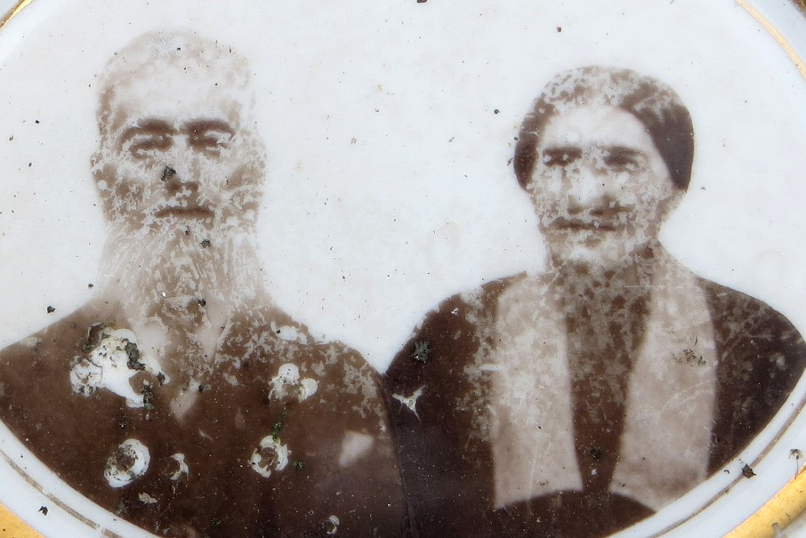
A ceramic photo of Pauline’s parents, Ferdinand Erschen and Magdalena Zwar, from their headstone in the Mozelj cemetery
Ferdinand and Magdalena had 10 children. One of their sons died in infancy, and is not listed in this table. Eight of the remaining nine children immigrated to America.
Erschen Children | Birth-Death | Immigration year | Immigration to | Death location if different
Pauline Erschen Gras | 1878–1931 | 1895 | Brooklyn
Ferdinand Erschen | 1880–1918 | Before 1909 | Brooklyn | PA
Josefa Erschen Heller | 1883–1927 | 1898 | Brooklyn
Maria (Mitzie) Erschen Schoenig | 1886–1958 | Before 1911 | US | St Louis, MO
Franz Erschen | 1888–1909 |  | Probably didn’t come to US | Died at age 20, no death record
Johann (John) Erschen | 1893–1955 | 1910 | New York
Rudolf Erschen | 1895–1931 | 1921 | Brooklyn (lived with Pauline in 1925 state census)
Julie Erschen Christos | 1897–1975 | 1920 | St. Louis | Queens
Magdalena (Lena) Erschen Jesche | 1900–1975 | 1922 | Queens
In addition to birth, communion, and wedding dates, the Nidermösel parish priest duly noted when and where each member of the family died. These parish records are called “Status Animarum,” or State of the Soul.
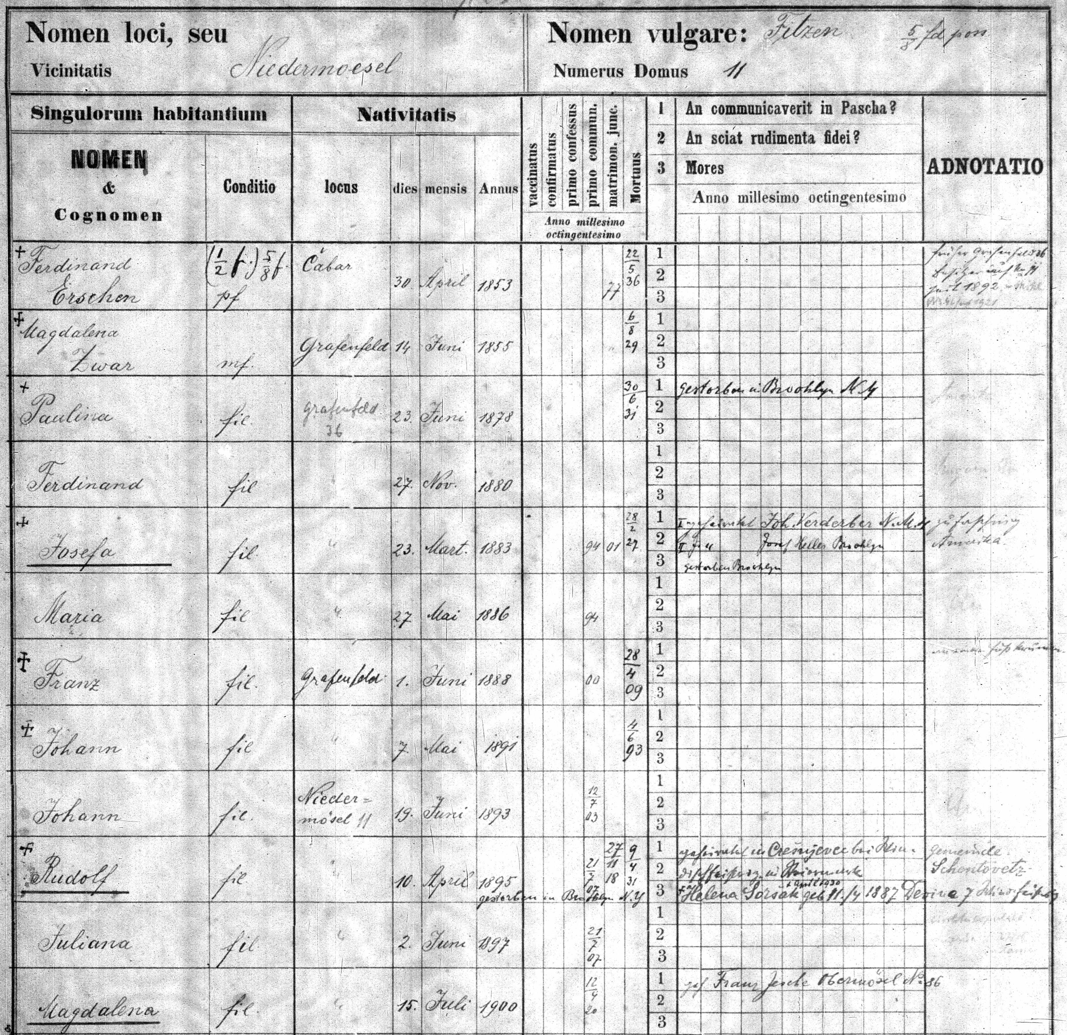
Erschen family page from the Nidermösel parish record, or Status Animarum
An average life span was 55 to 65 years. Ferdinand and Magdalena beat the odds, living to be 83 and 74, respectively. Cholera, typhoid, and tuberculosis killed many people. Childbirth was the main killer of women under 40.

The Friedrich Erschen Mystery
Pauline gave birth to Friedrich Erschen in 1901. The birth is listed as illegitimate in the parish record in Nidermösel, and the name (Gras) is enclosed in parentheses. It seems unlikely that Fred was Julius’s child, because Pauline and Julius didn’t marry until over two years after Fred was born. Yet Fred never lived with them, and their daughter, Heddy, never knew about Fred. If Pauline gave Fred up for adoption, why did he take the name Gras (he went by Fred W. Gras), and why were Pauline and Julius listed as his parents in his marriage and death records?
Interestingly, there is a military record for Friedrich Gras in the Bavarian army in 1918 in Julius's hometown of Rammelsbach.
Fred Gras married Anna Schetzer in 1927 in Manhattan. He died in 1930 at age 28 of carbon monoxide poisoning from the illuminating gas that was used to light homes (a common tragedy at this time in history). I did not find any record of Fred and Anna having children.
Fred’s death is not recorded in the Nidermösel parish register. Perhaps Pauline didn’t know about his death, which would suggest that she had not kept in touch with him.
In the 1910 census, Pauline says that she has only given birth to one child, Heddy.
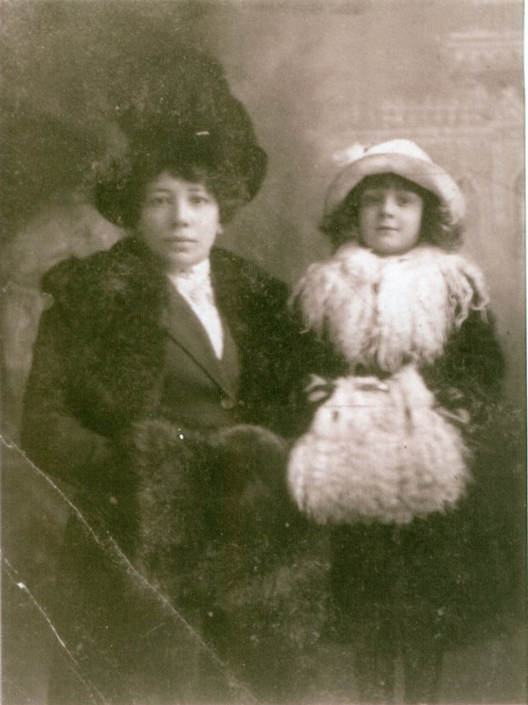
Pauline and Heddy Gras, circa 1913

