Gottschee County Information
When you research anything to do with Gottschee or the Gottscheers, always refer to the location as Gottschee, Krain, Austria. This will identify the area that is outside of today’s Austria. Otherwise, your computer will search for Austria as it is today and not the legacy Krain/Carniola areas.
Gottschee was an area of about 331 square miles. It was made up of 176 villages and 18 Roman Catholic Church Parishes. There were also townships, but that just causes more confusion than it is worth. Each parish was responsible for a number of villages and thus recorded all of their vital statistics within their domain. The parishes did not have an equal number of villages associated with them, so, you will find more villages in some parishes then others. As an example, the Mosel Parish had 14 villages within its responsibilities, the Gottenitz Parish had only two villages. Do not get confused by the fact that village names and parish names are the same in many cases. Take a look on the internet at wikipedia.org/wiki/Gottschee to get generalized information on Gottschee and its people. You can get detailed information on just about any village by clicking on the Slovenian name for that village. See also https://gottschee.org/.

Here are my comments on you family writeup.
Niedermosel – a village. It is not part of the village of Obermosel/Mosel. It is village and not a parish and kept no records. All records for Niedermosel village are located in the Mosel Parish church records.
Mosel/Obermosel – another village, albeit with two names. Mosel village is included in the Parish of Mosel. All records for this village are in the Mosel Parish church records.
Grafenfeld/Krapenfeld – another village with two names. All records for this village are in the Gottschee Parish church records.
Seele – another village. All records for this village are in the Gottschee Parish church records.

OTHER THINGS:
Women could inherit property, and they did! If no male descendent existed, the eldest female inherited the property.
Take a good look at the church record of Niedermosel #11 you included in your document. Upon closer examination, you will find that this not an ongoing list of what happened in this house. This document is like a ”census record” written by ONE scribe after the fact. The writing is perfect on the document. Not like done by several different individuals as events happened over a period of time. You can see the different writing to the right as information was added – they were not perfect and standardized.

Some information on a few of your villages from my manuscript. Please note, each village had its own church or chapel/Kapelle for local worship.

GRAFENFELD (Dolga Vas), Kropfnwold – In the land registry of 1574, Grafenfeld had 16 houses with 110-115 inhabitants. In 1770 there were 52 houses in the village. In 1910 the village had 86 houses and 266 inhabitants. Before the resettlement in 1941, there were 90 houses and 457 inhabitants. The church was dedicated to the Holy Name of Jesus and John and erected before June 1717.

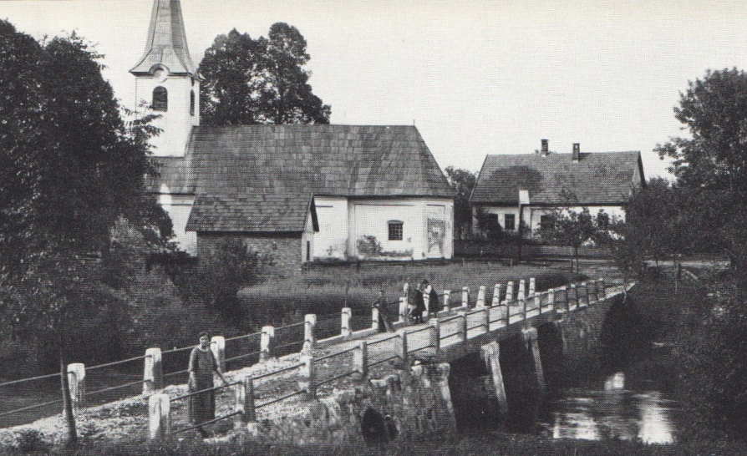
Grafenfeld and Church 1924

MOSEL/OBERMOSEL (Gorenji Mozelj), Mesl/Obermesl - Mosel was founded in 1509 and mentioned in the land register of 1574. The village, on a major communications road into Gottschee City, was an outlook post and used a fire signaling system to warn the city of approaching Turkish invaders. The first school was established in a village home in 1811 and replaced with a new school building in 1844. It was one of the larger schools and only one of 34 schools in Gottschee.

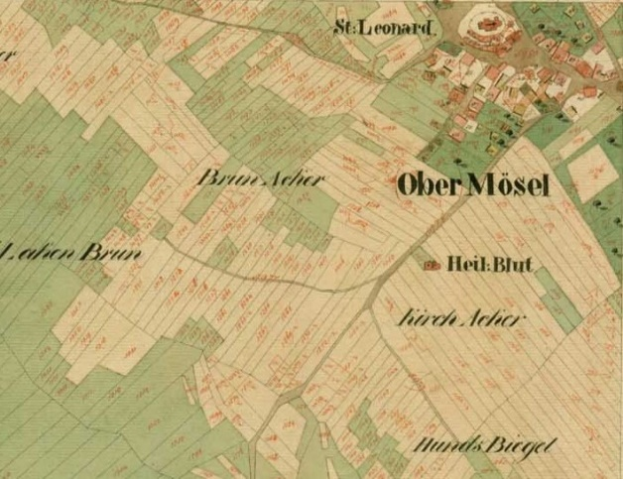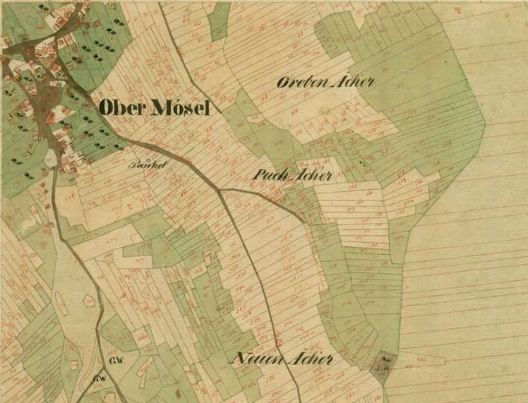
1824 – Cadastral Map Ober Mosel

Before WW II, Mosel had 65 houses. In June 1942, Italian occupation forces burned the village except for 13 houses. The cemetery located within the village still has Gottscheer graves and gravestones. The village church was first mentioned in the year 1360 and was known as the Most Precious Blood. In 1520 the parish church of St. Leonard was built.

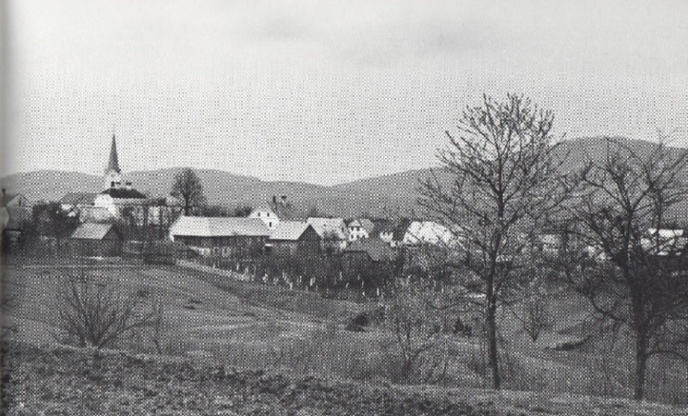
Mosel/Obermosel C 1934

Because the primary trade route north into Gottschee went through Mosel, helped it to grow into one of the largest villages in Gottschee. This major access route contributed to Mosel as the first location for a post office and resident mail carriers. With 89/96 houses, Mosel also contained a municipal office, a three-class room school, parish rectory, three inns, two merchants' shops, a bakery, a butcher, a tailor, a smithy, and a cement brick manufacturer. Children from Reintal, Niedermosel, Durnbach, and Otterbach attended the three-class room school.

NIEDERMOSEL (Spodnji Mozelj), Gotschara - The first mention of Niedermosel was in the 16th century. The church of St. Ambrosius was built in 1526. In 1941 there were 43 houses just before the resettlement of the Gottscheers to Rann (Brezice). Niedermosel was the site of a grist mill and served many villages for grain processing over the decades. Niedermosel was burned to the ground by the Italians in 1942 during WW II. It is today a shell of its former self.

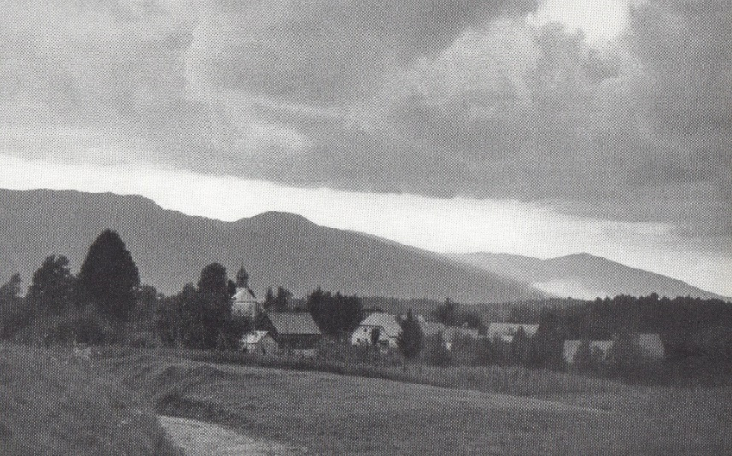
Niedermosel C 1935

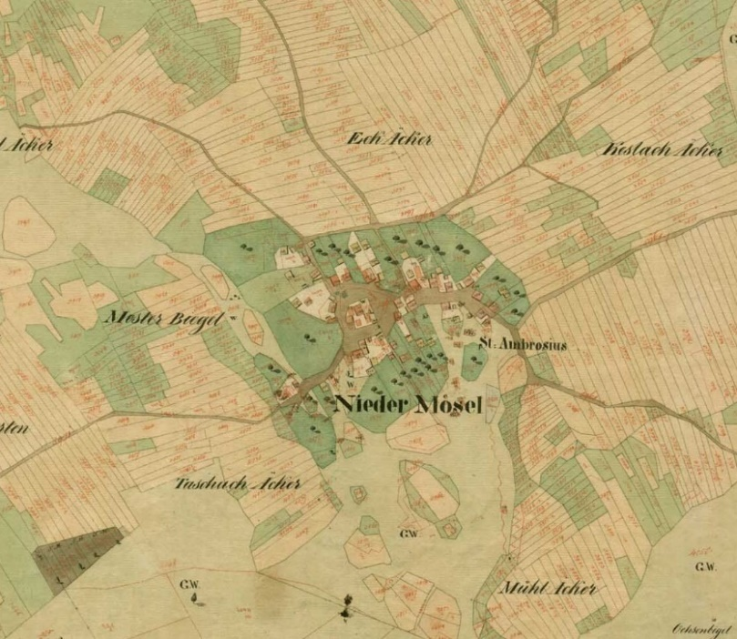
1824 – Cadastral Map Niedermosel

