**THE GOTTSCHEE**

**TRAMPOSCH AND GRAMER**

**FAMILY GENEALOGICAL HISTORY**

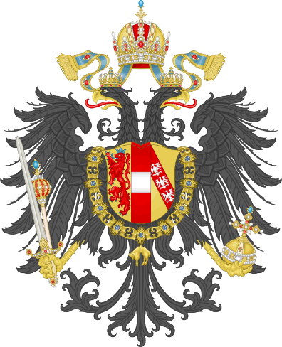 

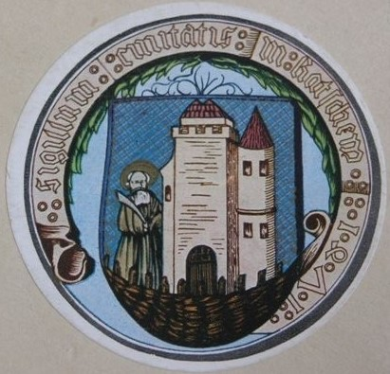

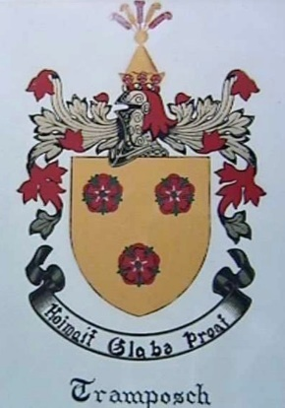

**Compiled by**

**Helmut Tramposch and Sophie Sandor**

**2017/2018 Revised 2019/2020**

**TABLE OF CONTENTS**

1. 1330 the Beginning
2. Tramposch Family History
3. Gramer Family History
4. Merger of Tramposch and Gramer Families
5. The Known Tramposch and Gramer Villages
6. Leaving Gottschee 1941-1942
7. On the Run - *Auf der Flucht* 1945
8. Displaced Person (DP) Camps
9. Relocating Gottschee Into the world
10. Gottscheers That Served in The Military
11. Tramposch and Gramer Detailed Genealogy
12. Some of Their Favorite Things
13. Miscellaneous Ramblings

On the cover: Coat of Arms, Seal and Crest Designation

**Austrian Coat of Arms**

**Coat of Arms - Counts of Ortenburg**

**Seal of Gottschee** Signumn Amtatis in Kotschem 1330-1941

Seal of Our Unity in Gottschee 1330-1941 (Patron saint was St. Bartholomaeus)

**Tramposch Crest** Hoaimot – Glabe – Proat (Gottscheer)

Heimat – Glaube – Brot (German)

Homeland – Faith – Bread (English)

***Preface***

The genesis of this manuscript was in the mid1970s to document the roots of the Heinrich Tramposch and Maria Pauline Gramer family. It was supposed to be a small paper that translated genealogy charts, so common in family research, into a readable everyday script.

I fled Yugoslavia in May 1945 at the age of 3 when WW II ended and returned in August 1978 to commence my journey of discovery. Little did I know how long the quest would take or how it would evolve. Before my visit, my father and mother asked that I visit the church in Kocevje and donate money to the priest for the upkeep of this historic church.

Upon meeting with the Slovenian priest, I found that we could not easily converse, but we did find we had a common language - German. During my visit, I asked if any records of Gottscheers were still available. He escorted me to a large library room within the rectory that contained several hundreds of original records dating back centuries. While looking at these records, I was surprised by the number of documents available. It was 1978, and the copy machine did not exist, and the transcribing of records would take forever. My only recourse was to take 35MM pictures of the pages about my family. That was the beginning, and I have since been researching my ancestors.

Over the years, I went from handwritten documents to crude computer files and eventually Family Tree Maker and Ancestry genealogy software.

Along the way, I discovered Gottscheer documentation and history. As an example, I spend every Wednesday evening for three months at the Library of Congress reading the archive copies of the Gottscheer Zeitung dating back to 1921. I made copies as needed and cataloged them. I soon concluded that I had a world of information to devour and organize.

When my parents passed away in 1991 and 1993, my sister Sophie Tramposch Sandor discovered that they had managed to escape Europe with numerous documents about themselves and, in turn, that of Gottschee and the Gottscheers. Sometime after that, I began to digitize all documents and photographs. When completed, I had thousands of family photographs and documents. These became the cornerstone of my research into Gottschee.

I soon realized that I did not know enough about Gottschee, its people, where they came from, how they got there, and how the villages impacted their evolution. I decided to take a deeper look and attempt to answer those questions.

This manuscript is the result of that analysis. I believe it to be a modest rendering of the Gottscheers and especially my ancestors.

I want to acknowledge the work done by my cousin Ruth Tramposch, who began the paper trail on the Tramposch family. My thanks also go to my sister Sophie for helping me keep my mind straight, giving me insight into life in Gottschee and pointing me in the right direction for further research.

I dedicate this manuscript to my parents, Heinrich and Maria Pauline Gramer Tramposch, all my ancestors, and the people of Gottschee.

**So where is Gottschee, Krain, Austria? Today it is known as Kocevje, Slovenia.**

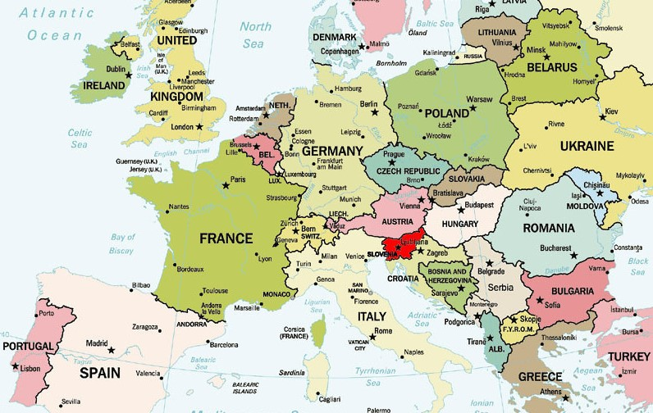

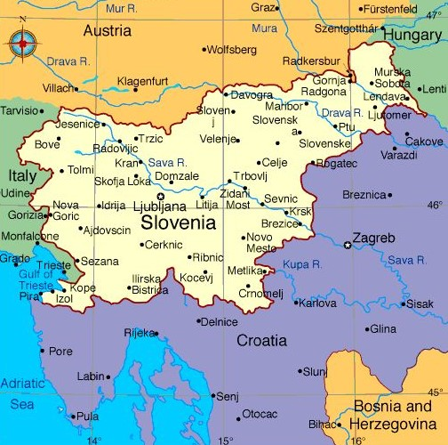

**Slovenia and Its Location in Europe**

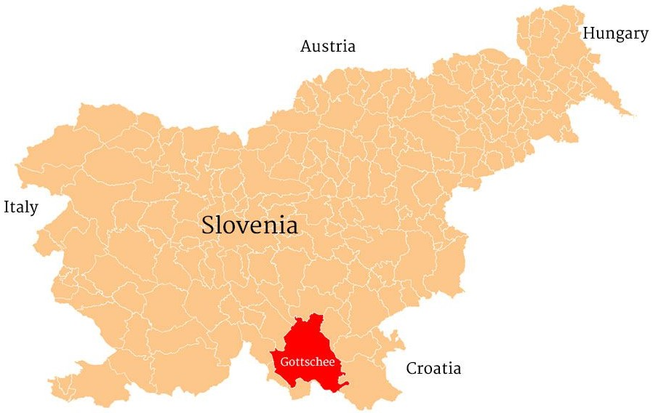

**Gottschee and Its Location in Slovenia**

***Chapter One***

***1330 The Beginning***

It is the middle ages, and the movement of peoples around Europe was in full swing. The period based on the growth in power of monarchies, the emergence of separate kingdoms (Hapsburg Empire), the growth of trade and urban life, and of course, the Catholic church.

This movement included the founding of Gottschee in1330. Who knew it would all end 611 years later? The beginning was the birth of Gottschee, and the end was the end of life as we lived it. It would endure at places other than where it had started. Austria, Germany, Canada, the USA, and other countries around the world would become the new Gottschee and keep the dream alive.

The first four families arrived in *Gatschen* on 10 August 1330. The village was to become Gottschee in later years, carved out of the uninhabited mountain forests. The identity of these families is unknown, but the remains of their house foundations can still be visited today.

The Carinthia counts of Ortenburg colonized the county of Gottschee with settlers from Carinthia and Tyrol, and by other settlers who came from the Austrian and German Dioceses of Salzburg, Brixen, Freising, and Thuringia.

Those chosen to relocate were young unmarried men and women who had to sign a contract that declared they would not return to their former homeland. The counts of Ortenburg provided travel protection using a small army of soldiers along the way. The counts guaranteed and provided two years of support for food and provisions at their destination. After their arrival, settlers had about six months to clear heavily forested land and built modest cabins to survive the first winter.

In 1350, the emperor made available 300 families from Thuringia in Germany. This group formed the basis of Gottschee County as a German-speaking language island mostly inhabited by Slovenians. As this was taking place, Europe was being devastated by the Black Plague (Bubonic Plague) that killed approximately 20 to 30 million people. These deaths were primarily in cities where the plague was able to spread due to close human contact with each other and city rats. The families that inhabited Gottschee during that period went mostly unaffected by this pandemic. Because cities in the area were nonexistent, and the plague was not known to spread within this emerging community

Settlement *(Ansiedlung)* of Gottschee:

This map depicts the five general areas that gave the German-speaking source for Gottschee. The chart shows the average distance from the origin to the Gottschee area and the approximate travel time between the two locations at the time.

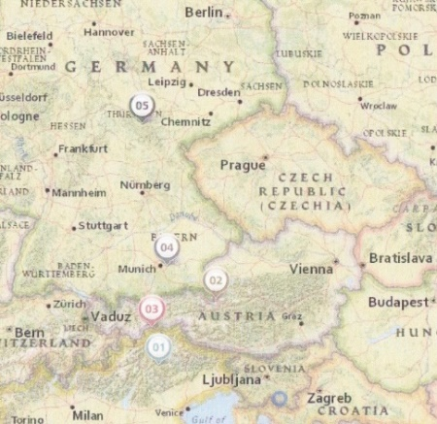

**Historical Gottscheer Origins (1300AD-1350AD)**

Origin Travel Via Route Distance in Miles Travel Time

Brixen, Austria (1) Georizia 231 11-15 days

Salzburg, Austria (2) Laibach 234 11-15 days

Tyrol, Austria (3) Villach, Laibach 285 14-19 days

Freising, Germany (4) Salzburg 319 16-21 days

Thuringia, Germany (5) Salzburg 500 25-33 days

**Note:** Travel time is calculated based on traveling by foot, oxen, mule, donkey or cow drawn carts over partially mountainous trails. Peasants typically did not have access to horses available only to the ruling class and their armies. I assumed that travels used the old Roman road system that peppered that part of the world and thus made travel a little bit easier and faster. Travelers most likely moved from sunrise to sunset and rested at the numerous waystations along the way. It is interesting to note that these travelers passed through the Karawanks mountain range to get to Gottschee. As fate would have it, they also used this same route to escape north to Austria in 1945, *Auf der Flucht* – representing the 24th generation of Gottscheers, 615 years later.

As the people of Gottschee continued to preserve the customs of their ancestors, they developed a distinct German dialect called *Gottscheerisch*. It was mainly a spoken language and those that were born there in1920,1930 and 1940s still alive speak the language today. German *Deutsch* was the formal written and spoken language used for day-to-day official communication.

Starting about 1469 and lasting until 1584, the Gottschee area was invaded by the Turkish Ottomans on numerous occasions. It is, therefore, not unrealistic that DNA may show connections to that part of the world.

In 1471, Gottschee received the municipal charter and city seal. In 1494 and then again in 1498, 1528/1538, 1564, 1568, 1570, and 1574 there were land registers (*Ubariums*) produced with statistics of land, the number of villages, names of the owners, and taxes. These serve as the basis of the genealogy records of the Gottscheers. The land registers for the years 1494 and 1498 are the oldest preserved record of the Gottscheers because there are virtually no records that depict the migration of the Germans to Gottschee. The best definitive information comes from the records of 1574.

Accordingly, the land records of 1574 state that the population of Gottschee county was between 8,600 to 9550 with 1545 dwellings. This population figure includes both Gottscheers, Slovenians, and others.

In 1574, Gottschee was under the control of the Hapsburg Archduke Carl. In 1641, Wolf Engelbrecht of Auersperg bought the county of Gottschee. In 1770, Maria Theresa ordered a count of all males who could be drafted into the Austrian army if needed. In that same year, all urban and rural dwellings were counted and recorded, and houses received house numbers.

In 1805-1806 Gottschee was occupied by Napoleon’s army and again in 1809-1814 became part of the French Illyrian providence. In 1809 the Gottscheers rebelled against the French culminating in the defeat of the Gottscheers and execution of numerous villagers. Some family names mentioned in the documentation include Eisenzopf, Jonke, and Erker. The defeat of the Napoleon army in 1815, meant the Gottscheers had relative peace until WW I.

In the year 1817, there were a total of 17,629 persons with 2,867 Slovenians included in this figure. In the year 1851, the population stood at 23,863, of which 2,938 were Slovenians. In the year 1857, there were 22,898 Gottscheers and an unknown number of Slovenians.

In the late 1800s, the Gottschee ethnic and linguistic area of 331 square miles consisted of 176 villages organized into 19 townships and 18 parishes. The population was about 26,000, and like many Slovenians and other Europeans, Gottscheers began to emigrate from their homeland since railway service reached the city in 1893. Many immigrated to various areas in the United States and Canada, with large numbers settling in Cleveland, Ohio, and Brooklyn, New York. Immigration was typically by individuals rather than whole families. Those that departed were usually the young men and women. Their parents generally remained behind to take care of the farmland and the grandparents. The normal mode of travel to “the new world” was via third class or tourist tickets on one of the many trans-Atlantic ships. The third-class passage was not elegant, but it was relatively inexpensive and affordable.

The assassination of Archduke Franz Ferdinand and his wife on June 28, 1914, precipitated the start of WW I in August 1914. Many Gottscheers fought in the war and were killed or went missing, but the numbers and the family names are still in question. The data are available in Austrian military records and documented in LDS microfilms.

In 1918, after World War I, with the dissolution of the Austro-Hungarian Empire, Gottschee became part of the province of Slovenia in the newly formed Kingdom of Serbs, Croats, and Slovenes. Gottscheers became citizens of the new country. In 1929, the kingdom became known as the Kingdom of Yugoslavia. Slovenia gained its independence from Yugoslavia in 1991. Today, the area of the former county of Gottschee is known as Kocevska, Slovenia. The city of Gottschee is known as Kocevje.

During World War II, the Gottscheers lost their homeland. When the German and Italian armies invaded Yugoslavia on 6 April 1941, an agreement between Mussolini of Italy and Hitler of Germany gave control of the Gottschee land area to Italy. Nine months later, the German government resettled the Gottscheer ethnic Germans from their 600-year homeland. Starting in November 1941 and completed in January 1942, almost 12,000 Gottscheers relocated to Brezice (*Rann*), Yugoslavia, which was annexed into the German Reich. Between 1941 and 1943, many of the Gottscheer villages were destroyed by the Italian forces in battles with the Yugoslavian partisans.

May 8, 1945, the Germans capitulated, and WW II was over – *Auf der Flucht* (On the run) begins. At the end of the war, the Gottscheers were forced to flee into Austria and Germany. Some of the refugees eventually found new homes there. Most, however, immigrated to the United States and Canada, where they had friends and relatives who had found a new life in those countries before World War I and II.

Today, the largest number of Gottscheers and their descendants live in the United States, most living in New York and Ohio, a smattering in Kansas, with smaller numbers living in Austria, Canada, Germany, and Slovenia. There are also small numbers of Gottscheers residing in England, Australia, and even Bangladesh. The world is today their homeland.

Family Naming Conventions:

The Germans that settled in the soon-to-be Gottschee were not of the aristocracy, and peasants were usually only known by their first names. As recorded in the land records, those names mostly depicted the landowners and taxpayers. As male children were born, they became known as “the son of.” As an example, the name Gaspar documented as Gaspar’s son or son of Gaspar. Eventually, in about the year 1500, a suffix found in Slavic surnames was added, such as “isch,” “usch,” etc. The name Gaspar became the last name of Gasparitsch. The Gottscheer surnames are the merging of the German and Slovenian languages. The Tramposch name most likely started as Tramp, Trampain, Trampein, Trump, or Trumpo and then morphed into Trampusch and then Tramposch. Still, in 1574, one-quarter of the Gottschee residents only went by first names and did not have last names.

Onomatology of Gottscheer Names:

The scientific study of the formation and origins of Gottscheer's names is well presented in the 1889 manuscript on Gottscheer names by Josef Obergfoll of Gottschee. The following list attempts to answer the questions of what the names mean, and from where they originated. Gottscheer names come from old German names, occupations, names attributed to combat or war phrases, and pet or animal names. A primer of selected ancestor family names follows:

Name Meaning/derivation

Eisenzopf Iron

Fritz Peace, security, protection

Gasparitsch Kaspar’s son (Kaspar one of the Three Kings of the bible)

Gramer Small shopkeeper, person by the ditch

Kofler Gently rising mountain ridge

Lackner From a place called Lack or Lag, forest dweller

Meditz Meeting place

Ostermann The east

Perz Bear

Peitler Purse maker

Putre/Puttrer To command

Rabuse Advice

Rom Raven, a sacred bird

Roethel Sound, fame

Stalzer (unknown)

Stimpfl Rigid, strong

Tanke Thought

Tramposch Name may be from pet/animal name - Trumbo, Trumpto or Trompe

Wolf Wolf, a sacred animal

Village Naming Conventions:

Village names had their birth in at least three ways. First was the naming of the village based on the landscape, e.g., the German description of the land. An example is the village of Hohenegg. It appears to be from the German meaning high (Hohen) and (eck), meaning high hillside.

The second methodology was the naming of the village based on its inhabitants. An example is Dorf der Meditz named so because the majority of families living there had the surname Meditz. This village later became Buchel.

The third naming protocol is the last name coming from the village itself. One example is Verderb village that gave birth to the name Verderber or one who comes from Verderb.

In reviewing the Gottscheer Zeitung of 1919-1941, I found that in the City and Land *(Stat und Land)* section, the editor of the newspaper used both the Slovenian and German names for villages. This section provided information on happenings in the city and the surrounding villages of Gottschee. Included were data on births, marriages, and deaths. More prominent deaths are on the last page of each edition outlined by a black border. I assume the more affluent families paid for these obituaries' inclusions.

House Naming Conventions

The naming of houses was used to define a specific family before the numbering of houses became the norm. Within villages, it was easy to find numerous families with the same last name. House names was a way to distinguish who was who. There has been much discussion on how these names began. One theory is that the names were of the first owners and the second, as the builder of the dwelling.

A review of these oeconyms appears to show that most were unique within the village and most ended in “sch.” An analysis of the Hohenegg village shows that out of the 48 houses, all but three ended in “sch.” The “sch” ending of houses appears to represent the possessive or “belonging to” such as Michitch house or Michitches. The “sch” in “son of” and “belonging to” appears to make sense. I will leave it to the reader to come to their conclusion. House numbers started in 1770 with the census ordered by the Austrian archduchess Maria Theresa.

One tradition that appears to be very consistent is the placing of a stone marker in the house architecture that defines the builder and year of construction. Such as “E1921M,” depicting that Edward Meditz placed the marker in 1921. These same markers were used to also commemorate the building year of other vital structures such as churches and water runs.

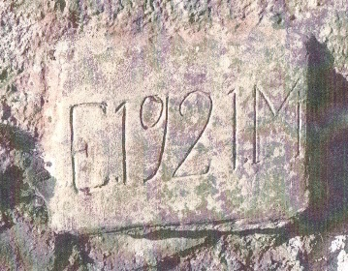

**House Marker Stone**

Religion and Churches

Gottscheers have historically practiced the Roman Catholic religion. The main church was St. Fabian and Sebastian, located in Gottschee City. The church is the largest of all Gottschee churches, and built-in neo-Romanesque style started in 1900 and completed in 1903. Each of the 18 parishes had its church of lesser size and prestige. The parish churches are where the vital records (birth, baptism, proclamation, marriage, death, etc.) of Gottscheers are recorded and kept. There never was a “government” entity who became involved in the recording of vital records, such as those in the USA. Within the villages, there were either a branch church or a chapel *(Kapelle)*. The amount of time and money these ornate churches cost the villagers attests to the importance of them to each village. In all, there were 123 churches/chapels in Gottschee. The parish of Mosel is used to show an example.

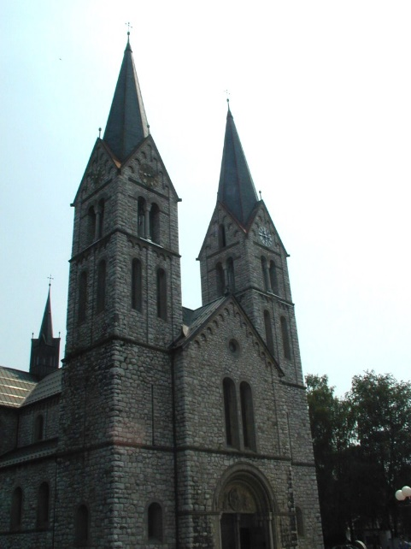 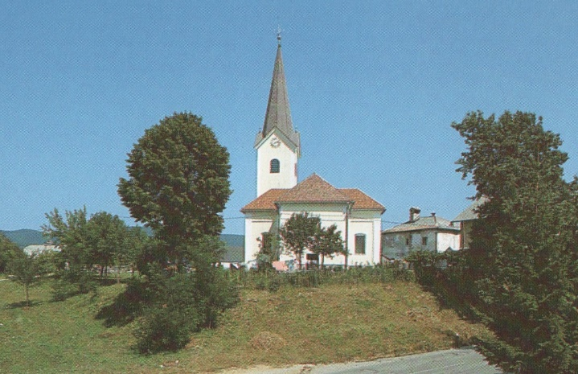

**St. Fabian and Sebastian - 2002** **Parish Church St. Leonard – Mosel**

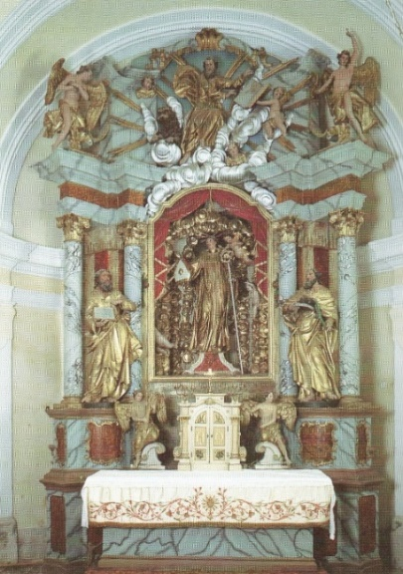

**The Altar at St. Leonard – Mosel Parish Church**

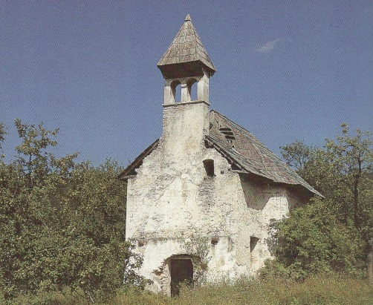 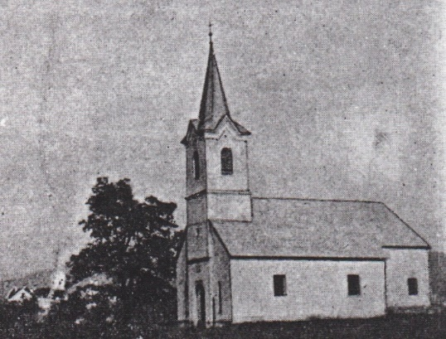

**Branch Church St. Andreas – Durnbach Kapelle Holy Blood - Mosel 1930**

Worship on Sunday was an obligation of every individual. Villages had one family that was responsible for maintaining and allowing access to the church as needed. This family was required to ring the branch church bell during the week to announce events such as the start of the work in the field, lunchtime, and the time to stop work. On Sunday, the bell announced the beginning of worship and the mass. During WW I most church bells were confiscated by the state and melted to provide armaments for the military. Most of these bells were replaced after the war as money became available to have them cast and reinstalled.

Gottscheer Cemeteries

Approximately 40 cemeteries existed in the 40,000 acres of land called Gottschee. These supported the burial needs of the 176 villages over the ages. While the Gottscheers occupied Gottschee, these cemeteries were taken care of and well maintained. After the Resettlement, *Umsiedlung* they fell in total disrepair as did the villages. During WW II, most villages, as well as most of the cemeteries, were destroyed by the battles that took place in the region. The rebuilding and occupation of Kocevje after the war saw a further decline of cemeteries in the area. With the Gottscheers gone, political factions in Yugoslavia saw no reason to maintain or even keep these cemeteries in existence. A systematic effort in 1954 started the eradication and removal of cemeteries by the communist regime. Gottscheer gravestones were toppled, removed, and used to build roads and houses. It is sad to note that the road-building effort not only used gravestones but that they were all placed face down almost as if to hide their legacy. Today, surviving cemeteries and their headstones have been remounted and placed along cemetery walls that line the cemetery. Although some graves and their tombstones have survived, they are mostly gone. An effort needs to be mounted to document these graves and headstones for future generations in resources such as Find a Grave.

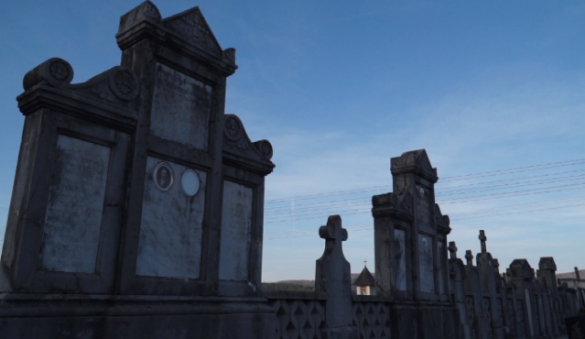

**Gottscheer Headstones Remounted in Cemetery Walls**